Quick Start user guide:

1. System_Gui.py is the Main script

python /Users/hongyuzhang/Desktop/CS6360Project/CS6360/System_Gui.py

1. The System GUI lists all the functions this software can do

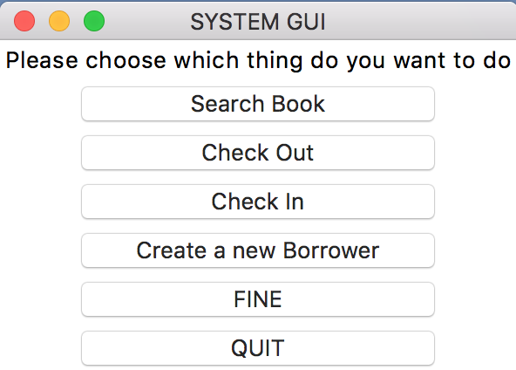

1. Search Book:

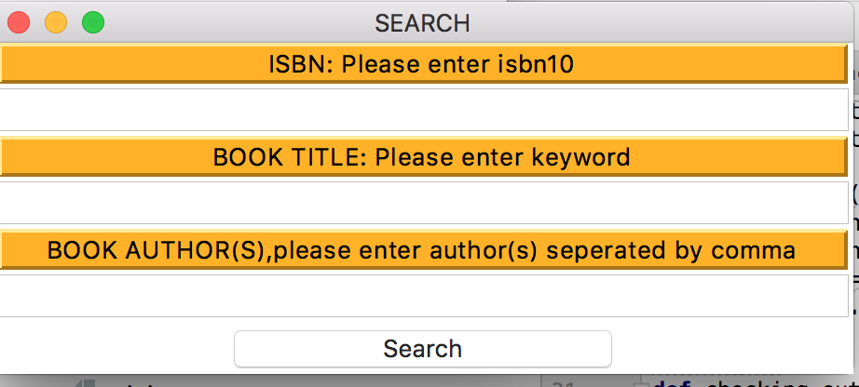

the search logic is ISBN or BOOK TITILE or BOOK AUTHORS

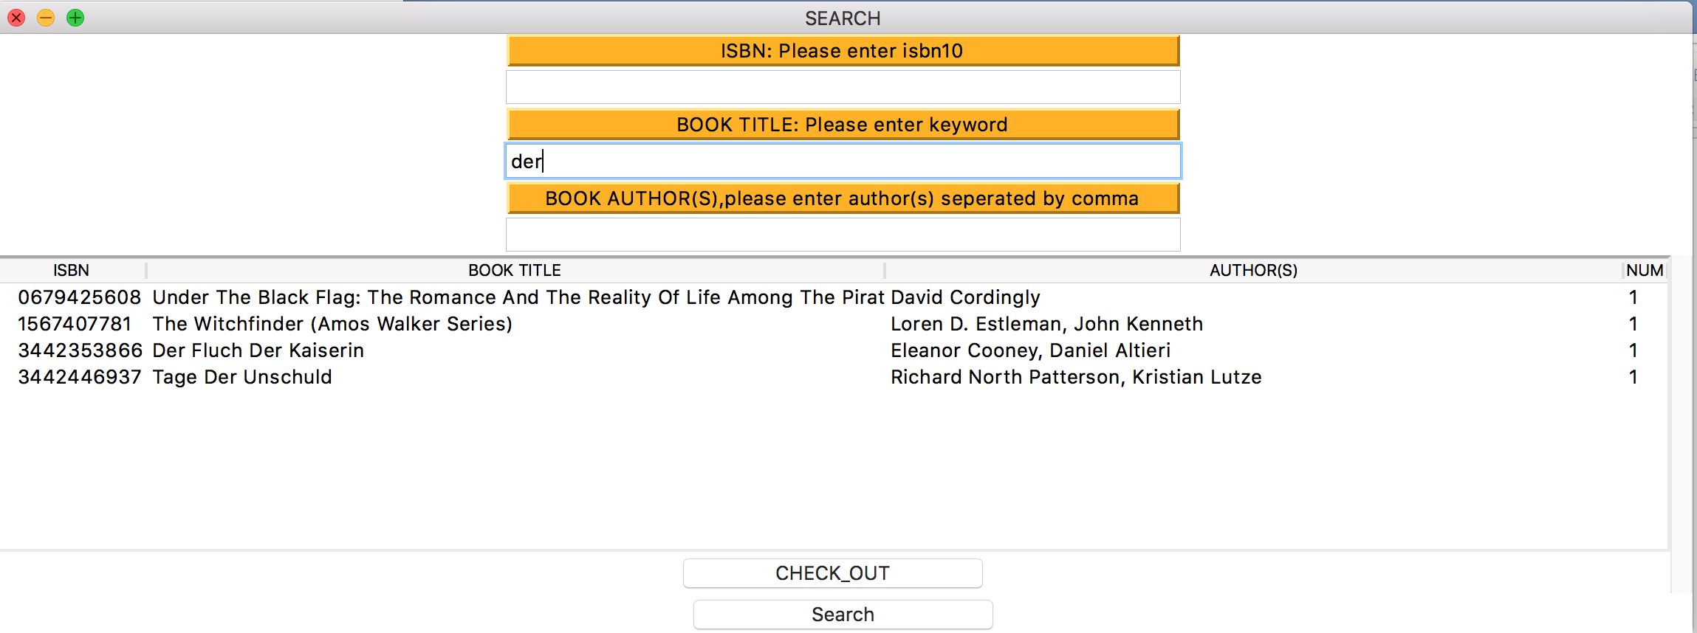

If you find the book needed, you can check out directly

1. Check Out:

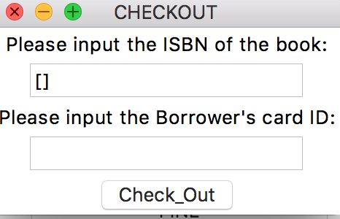

if you know the ISBN of the book, check out directly

1. Check In:

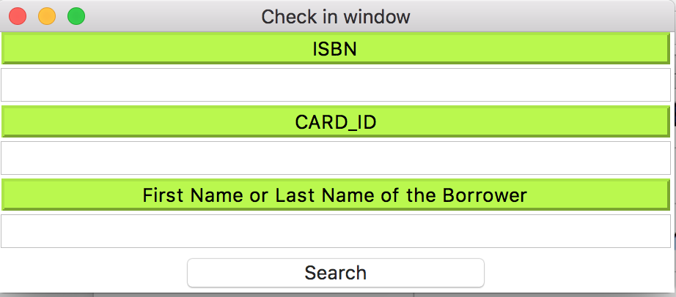

the search logic is ISBN or CARD_ID or NAME

1. Create a Borrower

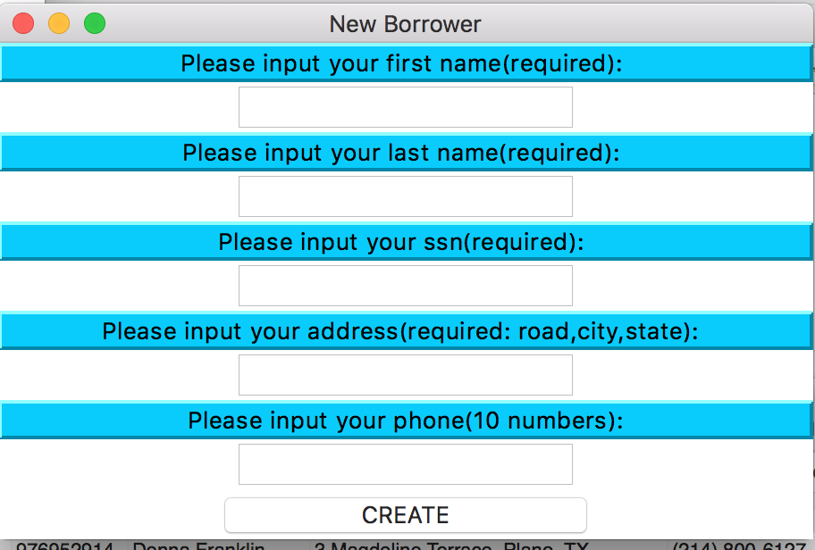

1. Fine

Update all Fines: Update every loans’ fines

Show Fines: Given a card_id, you can find all fines related to this card_id

